# Deployment Steps

1. Set up two web sites in IIS. For web app and API

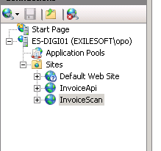

1. The folder which web contents goes should be names as ‘Exf.InvAppr.Web’. Because files paths are taken using the folder path.

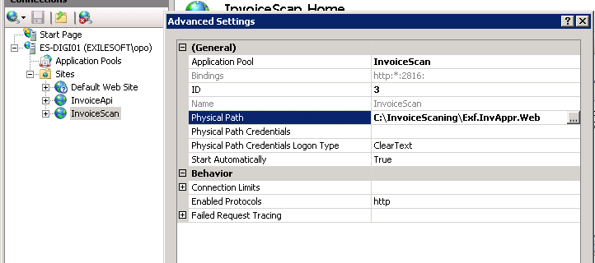

1. Set configuration values in appconfig section of the web.config of the API

<appSettings>

<add key="webpages:Version" value="3.0.0.0" />

<add key="webpages:Enabled" value="false" />

<add key="ClientValidationEnabled" value="true" />

<add key="UnobtrusiveJavaScriptEnabled" value="true" />

<!--Email sending-->

<add key="EmailServer" value="smtp.office365.com" />

<add key="EmailPort" value="587" />

<add key="EmailUsername" value="smtp@exilesoft.com" />

<add key="EmailPassword" value="Ak2ok46@h&amp;T^E!!" />

<add key="EmailFromAddress" value="smtp@exilesoft.com" />

<add key="EmailDisplayName" value="Invoice Management System" />

<add key="localInvoicePath" value="scannedInvoices" /> <!--This is the folder inside the site structure which use to store images in non- azure deployemnts-->

<!--Visma-->

<add key="VismaUser" value="system" />

<add key="VismaPassword" value="eXile123" />

<!--Azure-->

<add key="IsDeployedInAzure" value="false"/>

<add key="StorageConnectionString" value="DefaultEndpointsProtocol=https;AccountName=invoicescan;AccountKey=x5uQUiCEFX1TyFMg0Re8igYU8cnxPdS6IWZZAR =="/>

</appSettings>

1. Create Folders to keep invoices. The folder name should be the one given as above localInvoicePath. Also create sub folders to hold invoice images. Sub folder names should be found from the data base region table.

<add key="localInvoicePath" value="scannedInvoices" />

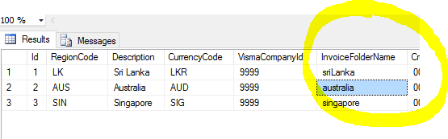

1. Set web service url for the visma

<client>

<endpoint address=<http://192.168.132.158:2001/GenericService>

…

….

1. Set web Api url. Go to …\Exf.InvAppr.Web\app\services\appConfigService.js. Change the service url.

(function () {

angular.module('AngularAuthApp').constant('app_config', {

SERVICE_BASE: 'http://localhost:1212/',

1. Change the server address of the link found in NewUserApprovedTemplate.html.

Your user account request is approved. Click on <a href="http://localhost:9999/index.html#/login">here</a> to login.

…\Exf.InvAppr\Exf.InvAppr.Common\Email\MailTemplate\NewUserApprovedTemplate.html